Exercises – Microsimulation models

Decision Analysis in R for Technologies in Health

|  |  |
| --- | --- |
|  |  |
| Fernando Alarid-Escudero, PhD1  Eva A. Enns, MS, PhD2  M.G. Myriam Hunink, MD, PhD3,4  Hawre J. Jalal, MD, PhD5  Eline M. Krijkamp, MSc3  Petros Pechlivanoglou, PhD6 |  |

Acknowledgements and attribution.

Please cite the following papers when using any of the material:

[Jalal H, et al. An Overview of R in Health Decision Sciences. Med. Dec. Mak. 2017; 37(3): 735-746.](https://www.ncbi.nlm.nih.gov/pubmed/?term=overview+of+R+jalal)

Krijkamp EM, et al. Microsimulation modeling for health decision sciences using R: a tutorial. Med. Dec. Mak. 2018

Enns, EA, et al. Identifying Best-Fitting Inputs in Health-Economic Model Calibration: A Pareto Frontier Approach. Medical Decision Making, 35(2), 170–182.

In collaboration of:

1 Center for Research and Teaching in Economics (CIDE), Drug Policy Program, Mexico

2 University of Minnesota School of Public Health, Minneapolis, MN, USA

3 Erasmus MC, Rotterdam, The Netherlands

4 Harvard T.H. Chan School of Public Health, Boston, USA

5 University of Pittsburgh Graduate School of Public Health, Pittsburgh, PA, USA

6 The Hospital for Sick Children, Toronto and University of Toronto, Toronto ON, Canada

|  |  |
| --- | --- |
| **Title** | A Microsimulation model – The Sick-Sicker model |
| **Topic** | Microsimulation |
| **Learning objective** | To digest the R code presented about microsimulation  To be able to build a microsimulation model  Adding memory and baseline characteristics **+ state residency** |
| **Specifications** | Microsimulation, 4 alternatives, cost-effectiveness |
| **Duration** | 40 minutes |
| **Needed** | Exercise instruction, R, R-studio |

### Exercise I: A Microsimulation model – The Sick-Sicker model

In this exercise, we will model the hypothetical Sick-Sicker disease using a microsimulation model. The Sick-Sicker disease has been previously modeled as a Markov model using four health states (Figure): Healthy (H); two disease states, Sick (S1) and Sicker (S2); and Dead (D).

Two of the advantages of using a microsimulation implementation, which are to incorporate i) ‘memory’ into the disease dynamics and ii) variation in the baseline characteristics for every individual. To illustrate this, we extend the Sick-Sicker microsimulation model to include memory effects and patient heterogeneity at baseline. Specifically, we assume that the individual mortality rate increases the longer a patient spends in one of the sick states and that effectiveness of treatment is dependent on the duration of stay in the sick states and on baseline characteristics. Healthy individuals still have a death rate based on the Human Mortality Database.

Three modifications were made to the model:

1. The mortality rates depend on age
2. **The mortality rates in the sick/sicker states depend on the duration of remaining in the disease states (see Table).**
3. The improvement on quality of life by the treatment varies across individuals through a characteristic that acts as a treatment effect modifier. All model parameter values and R variable names are presented in the Table.

After you have successfully implemented the natural history of the Sick-Sicker disease as a microsimulation, you can expand the model to include the possibility of treatment and evaluate whether it is cost-effective given a willingness to pay of $20,000. This hypothetical treatment improves the quality of life for those in the Sick state; however, it is not possible to distinguish between individuals in the Sick state from those in the Sicker state, so under a treatment strategy, individuals in both sick states must be treated (and incur the costs of treatment). Treatment parameters are also summarized in the table below.

## Tasks

There are quite some steps you need to take in order to create a microsimulation reflecting this case.

1. Open the Microsimulation student template to load the data for the time dependency and the individual characteristics. This templates makes use the files called mortProb.csv and MyPopulation-AgeDistribtion.csv
   * Start adjusting the Probs(), Costs() and Eff() functions to incorporate the new case
2. Simulate a population of 100,000 individuals and plot the resulting distributions of remaining lifetime costs and QALYs.
3. Expand your microsimulation to include the possibility of the hypothetical treatment for the Sick-Sicker disease (and its impact on costs and quality of life). Create a new variable, “i.s” that can be set to “Treatment” or “No Treatment” to turn treatment on and off in the model.
4. Simulate a population of 100,000 individuals under a treatment strategy where anyone who is sick (in the Sick or Sicker states) receives treatment. Plot the resulting distributions of remaining lifetime costs and QALYs.
5. Calculate the incremental cost-effectiveness ratio of treatment compared to no treatment.

#### Table 1: Input parameters for the time dependent Sick-Sicker Microsimulation

|  |  |  |  |
| --- | --- | --- | --- |
| **Parameter** | **Variable name in R** | | **Value** |
| Time horizon | | n_t | 30 years |
| Cycle length | | cl | 1 year |
| Number of simulated individuals (*ni*) | | n_i | 1000 |
| Names of health states (*n*) | | v_n | H, S1, S2, D |
| Annual discount rate | | d_r | 3% |
| Population characteristics | |  |  |
| Age distribution | | -- | Range: 25-55 distributed as in “MyPopulation-AgeDistribution.csv” |
| Annual transition probabilities | |  |  |
| Disease onset (Η to S1) | | p_HS1 | 0.15 |
| Recovery (S1 to Η) | | p_S1H | 0.5 |
| Disease progression (S1 to S2) | | p_S1S2 | 0.105 |
| Annual probability of death | |  |  |
| H to D | | p_HD | Human Mortality Database: age dependent from 2015 |
| Probability of death in S1 | | p_S1D |  |
| Cycle 1 | |  | 0.0149 |
| Cycle 2 | |  | 0.018 |
| Cycle 3 | |  | 0.021 |
| Cycle 4 | |  | 0.026 |
| Cycle 5 | |  | 0.031 |
| Cycle 6 and on | |  | 0.037 |
| Probability of death in S2 | | p_S2D | 0.048 |
| Annual costs | |  |  |
| Healthy individuals | | c_H | $2000 |
| Sick individuals in S1 | | c_S1 | $4000 |
| Sick individuals in S2 | | c_S2 | $15000 |
| Dead individuals | | c_D | $0 |
| Additional annual treatment cost per sick individual (S1 and S2) | | c_Trt | $12000 |
| Utility weights | |  |  |
| Healthy individuals | | u_H | 1.00 |
| Sick individuals in S1 | | u_S1 | 0.75 |
| Sick individuals in S2 | | u_S2 | 0.50 |
| Intervention effect | |  |  |
| Utility for treated individuals in S1 | | u_Trt | 0.95 |
| Time varying extension of Sick-Sicker model | |  |  |
| Treatment effect modifier at baseline | | v_x | *Uniform*(0.95, 1.05) |

# Results

All results were generated with seed=1.

Strategy: no treatment

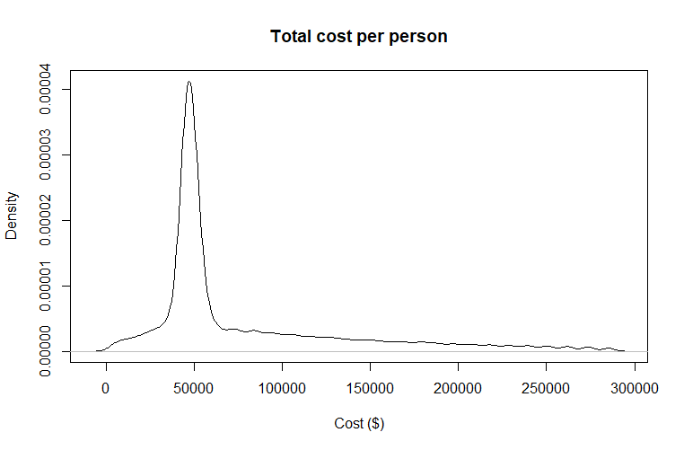

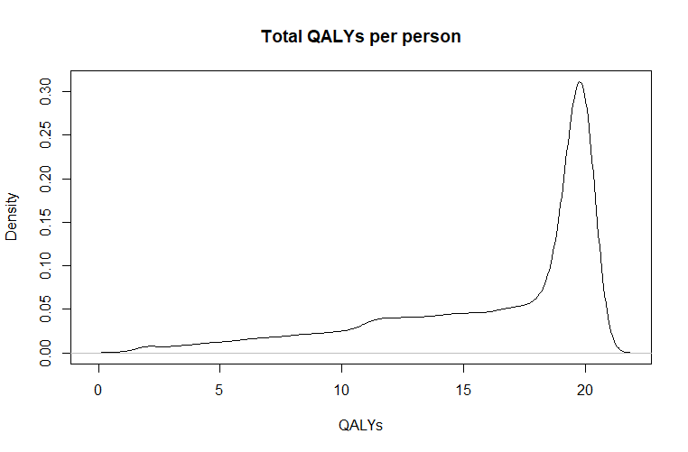

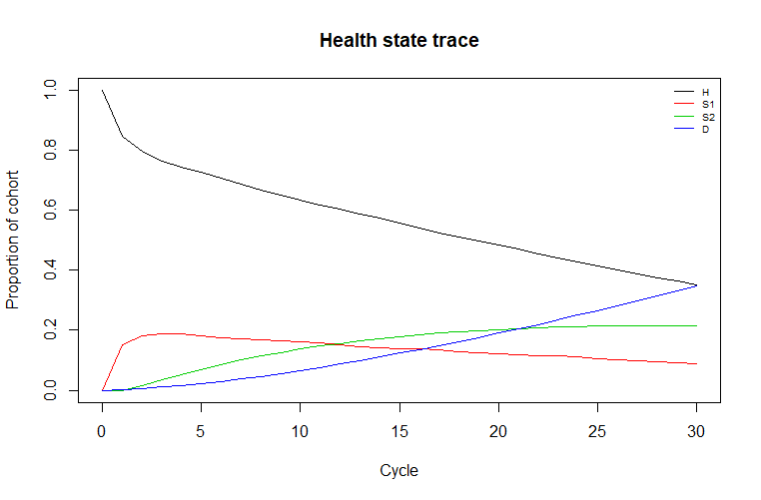

Strategy: treatment

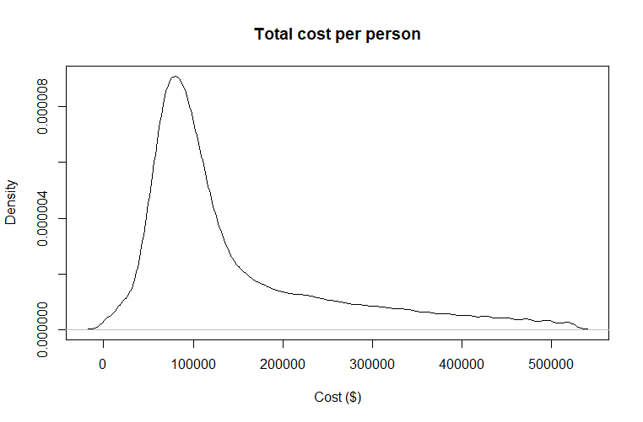

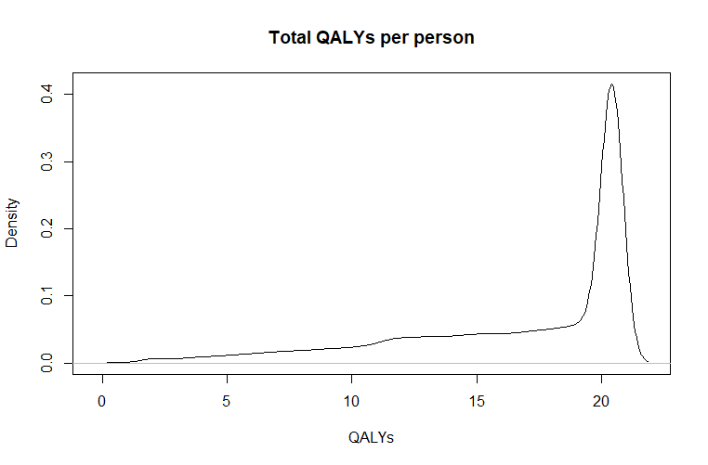



Strategy Cost Effect Inc_Cost Inc_Effect ICER Status

1 no treatment 77752.46 16.19202 NA NA NA ND

2 treatment 144839.47 16.76875 67087.01 0.576735 116322.1 ND